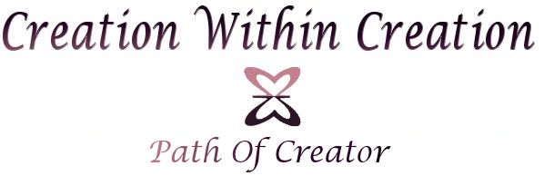

www.CreationWithinCreation.com

Your Negative Ideas

Created by

Jonny John Liu

**Instructions**

If you wish you can use this worksheet to store all your Negative Ideas so that you can keep a record of all the suffering states of mind that you are working on. And if you wish to work through them simply use my [website](http://www.creationwithincreation.com) for free resources.

|  |  |  |  |
| --- | --- | --- | --- |
| **The Creator's Worksheet**  **Negative Ideas** | | | |
| **Negative Ideas** | **Potentiated Ideas** | **Expanding The Negative Ideas**  (We will cover this in the Section - Negative Ideas) | **Transforming The Negative Ideas.** Write down the List of things you can do in your life to transform the Negative Ideas to the Potentiated Ideas  (We will cover this in the Section - Catalysts) |
| i.e. "It is not ok to fail" | i.e. "It is ok to fail" | i.e. "It is ok to fail" |  |
|  |  |  |  |
|  |  |  |  |
|  |  |  |  |
|  |  |  |  |
|  |  |  |  |
|  |  |  |  |
|  |  |  |  |
|  |  |  |  |
|  |  |  |  |
|  |  |  |  |
|  |  |  |  |
|  |  |  |  |
|  |  |  |  |
|  |  |  |  |
|  |  |  |  |
|  |  |  |  |
|  |  |  |  |
|  |  |  |  |
|  |  |  |  |
|  |  |  |  |
|  |  |  |  |
|  |  |  |  |
|  |  |  |  |
|  |  |  |  |
|  |  |  |  |
|  |  |  |  |